The Yelp Elite: Do they matter, and who are they?

# Problem and hypothesis



The Yelp Elite is a distinction made to reward members of the Yelp community who have developed a strong track record on the site. However, when it comes to understanding their actual power, we ask the following:

How different are the Yelp Elite from the general community and do their reviews have more impact on a business's success?

Our hypothesis is that the Yelp Elite are a more discriminating bunch of Yelp members and that their reviews will be a better “first stop” to look at when determining where to visit.

Our project will consist of three primary analyses:

1. To see whether or not Elite reviewers are actually better a predicting a business success
2. To see what user characteristics predict whether or not they are elite
3. To visualize and understand Boston-specific Elite reviewers

# The data

While there were several datasets available for use, our focus was on three particular datasets:

(1) Dataset of user profiles that included the user ids as well as a number of important variables on that user’s site behavior, as well as the years when the member was considered "Elite". Our target variable will be drawn from this dataset. The following variables are included in the dataset:

|  |  |
| --- | --- |
| average_stars | float64 |
| compliments_cool | float64 |
| compliments_cute | float64 |
| compliments_funny | float64 |
| compliments_hot | float64 |
| compliments_list | float64 |
| compliments_more | float64 |
| compliments_note | float64 |
| compliments_photos | float64 |
| compliments_plain | float64 |
| compliments_profile | float64 |
| compliments_writer | float64 |
| elite | object |
| fans | int64 |
| friends | object |
| name | object |
| review_count | int64 |
| type | object |
| user_id | object |
| votes_cool | int64 |
| votes_funny | int64 |
| votes_useful | int64 |
| yelping_since | object |

Table 1: User Table Schema

(2) Dataset of individual reviews that includes the userid and date of review so that it can be matched with the userid table

|  |  |
| --- | --- |
| business_id | object |
| date | object |
| review_id | object |
| stars | int64 |
| text | object |
| type | object |
| user_id | object |
| votes_cool | float64 |
| votes_funny | float64 |
| votes_useful | float64 |

Table 2: Review Table Schema

(3) Dataset of business information that includes the category of the business as well as the star rating of the business overall

|  |  |
| --- | --- |
| attributes_Accepts Credit Cards | object |
| attributes_Accepts Insurance | object |
| attributes_Ages Allowed | object |
| attributes_Alcohol | object |
| attributes_Ambience | object |
| attributes_Attire | object |
| attributes_BYOB | object |
| attributes_BYOB/Corkage | object |
| attributes_By Appointment Only | object |
| attributes_Caters | object |
| attributes_Coat Check | object |
| attributes_Corkage | object |
| attributes_Delivery | object |
| attributes_Dietary Restrictions | object |
| attributes_Dogs Allowed | object |
| attributes_Drive-Thru | object |
| attributes_Good For | object |
| attributes_Good For Dancing | object |
| attributes_Good For Groups | object |
| attributes_Good For Kids | object |
| attributes_Good for Kids | object |
| attributes_Hair Types Specialized In | object |
| attributes_Happy Hour | object |
| attributes_Has TV | object |
| attributes_Music | object |
| attributes_Noise Level | object |
| attributes_Open 24 Hours | object |
| attributes_Order at Counter | object |
| attributes_Outdoor Seating | object |
| attributes_Parking | object |
| attributes_Payment Types | object |
| attributes_Price Range | float64 |
| attributes_Smoking | object |
| attributes_Take-out | object |
| attributes_Takes Reservations | object |
| attributes_Waiter Service | object |
| attributes_Wheelchair Accessible | object |
| attributes_Wi-Fi | object |
| business_id | object |
| categories | object |
| city | object |
| full_address | object |
| hours_Friday | object |
| hours_Monday | object |
| hours_Saturday | object |
| hours_Sunday | object |
| hours_Thursday | object |
| hours_Tuesday | object |
| hours_Wednesday | object |
| latitude | float64 |
| longitude | float64 |
| name | object |
| neighborhoods | object |
| open | bool |
| review_count | int64 |
| stars | float64 |
| state | object |
| type | object |

Table 3: Business Table Schema

Note that in pandas object variables tend to be string objects

Each of these datasets was publicly available through Yelp’s Data Challenge. <http://www.yelp.com/dataset_challenge>

The data used for Analysis 3 on the Boston Elites had to be scraped separately using iMacros web scraping. Boston data was not part of the publicly available dataset that Yelp provided for the data challenge. This also means we were not able to get all the variables that were provided. However, we were able to get categories of businesses that are attended by Boston elite as well as their ratings, and characteristics of the businesses they visit – which is the primary focus on the analysis. Further details for the scraping can be found in the Analysis III python files.

# Pre-processing steps

**Initial File Type Conversion**

Before any data manipulations could occur to run models, we had to convert JSON formatted Yelp! files to a csv format to be workable for our purposes. We had to convert the JSON strings that were extracted to a flat Python dictionary which could then be passed into Pandas. To do this, we used a convert function like in Figure 1.

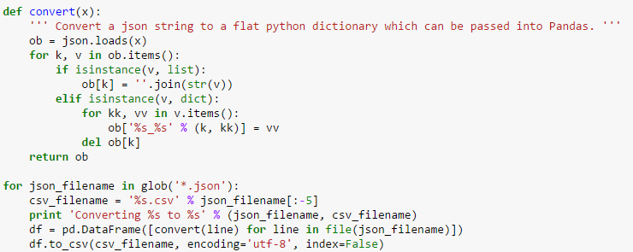

Figure 1:Conversion function to convert JSON to CSVs

**Pre-Processing the Users Table**

There were a number of steps that needed to be taken, in particular, to identify reviews that actually came from Elite members.

The first step in this process was sub-setting the user table to user id and the elite variable, which unfortunately, was stored as a string of a years that needed to be converted to an array that could be then further split.

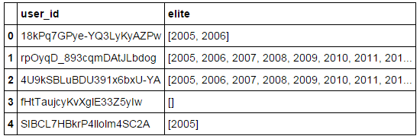

*Figure 1: Elite column is stored as string*

In order to assure that in cases where the array was blank that there was indeed a blank, the length was then taken of the generated array to help gauge the number of years that a user was part of the elite.

One the length was determined and non elite users (eg. Length=0) was removed, we created unique user_id – year pairs that we threw into a pandas dataframe as shown in Figure 2.

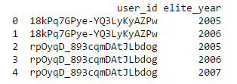

Figure 2:Unique user/year combination dataframe

**Pre-Processing the Reviews Table**

Within the reviews table, the first order of business was to coerce the date field into a pandas version of dates that can be used for additional analyses. Once the date field becomes a pandas date object, we were able to quickly extract the year that will be concatenated with the user id to give us an indexing column that we can use to merge with the user table -- giving us the ability to flag particular reviews as coming from an elite source.

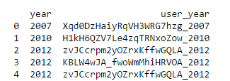

*Figure 3: User, Year combination in Reviews Data File*

Once the review table is tagged with elite and non-elite, we merge it with the business table in order to exact the Las Vegas business ids. In order to do this, we first filter the business table by location using the city variable:

business3=business2[business2["city"] == "Las Vegas"].squeeze()

Afterwards, we do an inner join of the filtered Las Vegas business table with the tagged reviews table to just include review of Las Vegas businesses using the merge:

merge=pd.merge(business3, review, on='business_id', how='inner')

# data exploration

Approximately 10% of businesses in the Las Vegas dataset we worked with had star ratings of 5 on Yelp's scale (that has spacing of 0.5 increments). There were a total of 13,601 unique businesses used in the analysis for Las Vegas. The data is right skewed with very few businesses having star ratings of 2 and below. The average rating is 3.66.

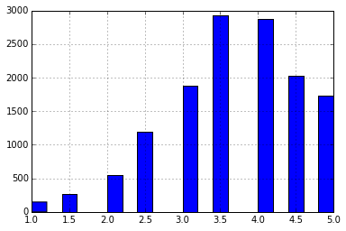

*Figure 4: # of businesses with star ratings of...*

It also appears that we should have a significant result in our model on whether or not elite reviewers have a different take on restaurant success if we look at the rating behavior of the elite versus non-elite reviewers as seen below:



*Figure 5: Rating behavior of elites versus non-elites*

In terms of the users that are being modeled in the second analysis, their average stars are relatively in line with the overall business ratings, being skewed to the right with a median of 3.86, as seen in the descriptive stats from Figure 5.

A couple of other noteworthy points from the descriptive statistics that will be important considerations when looking at the modeling algorithms:

* Regardless of elite status, the two most common compliments received by users are simple “Thank You” messages with no connotation included and cool and hot. The compliment handed out the least is for the reviewer to “write more”
* Not surprisingly, the compliment with the most variance is on photos – likely driven by the fact that not all reviewers include photos to be commented on in the first place. Of interest, however, is that although the generic “Thank You” would appear to be handed out most often, it also has the most variance, indicating a strong skew in the data (and probably an outlier).

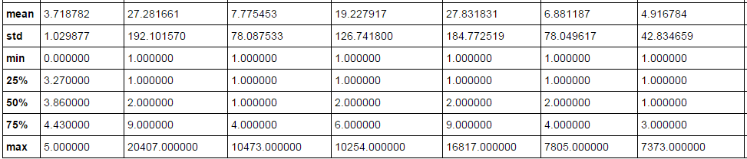

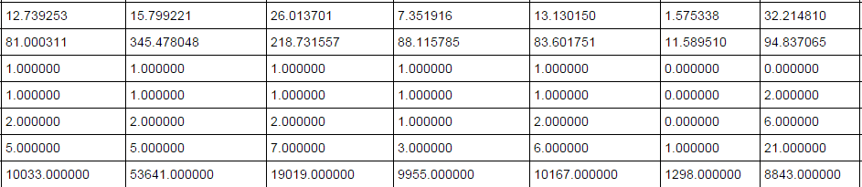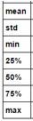

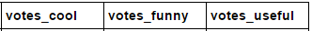

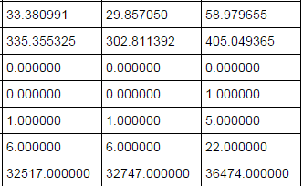

*Figure 6: Descriptive Statistics from input variables*

# how you chose which features to use in analysis

For analysis one, the choice of features was very straightforward, which is also why we selected the more straightforward logistic regression to do the analysis. We were only concerned with whether or not the Elite population’s reviews were indeed more predictive of the restaurant’s review overall, as compared to non-Elite reviewers.

For the second analysis, feature selection was limited to user characteristics that were directly linked in the user table. These included features about their behavior on Yelp as well as the types of reactions they received to their reviews from the wider Yelp audience.

In addition, the descriptive statistics ran in Section 4 helped to identify variables that we might want to exclude from analysis simply because they did not vary enough, especially when we looked at it from an elite/non-elite perspective. There didn’t appear to be any statistically significant difference in the group means.

The third analysis was largely predicated on the results of the analysis on elites with fans versus elites without fans and looking at the types of restaurant categories were frequented, largely as a novel interest from being in the Boston area.

# details of modeling process

Analysis I:

Analysis II a:

One of the regressions we did was to predict whether a user is elite or not using data from the user table. In order to do this, we took the elite users table we previously created and tagged a user as elite if they are in the elite users table and zero otherwise.

user_merge['is_elite']=user_merge['user_id'].apply(lambda x: x in ids)

user_merge.is_elite = user_merge.is_elite.astype(int)

After the user table is labeled as elite and non-elite, we took the filtered review table and extracted the user ids and inner joined the extracted user ids to get only users who reviewed Las Vegas restaurants.

Another preprocess, I did before modeling is to count the number of friends to create a friends variable. In order to do this, I converted the friends variable to an array and then assigned the length to the new friends variable

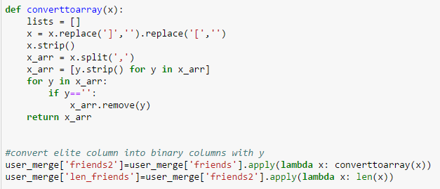

Figure 3: Calculation of the friends column

Once the user table is processed, I began to prepare it for modeling. In order to do so, I ran the functions created in class to impute missing variables, remove variables with no variance, delete variables with perfect correlation, and scale variables. Since there were no string features there was nothing to binarize.

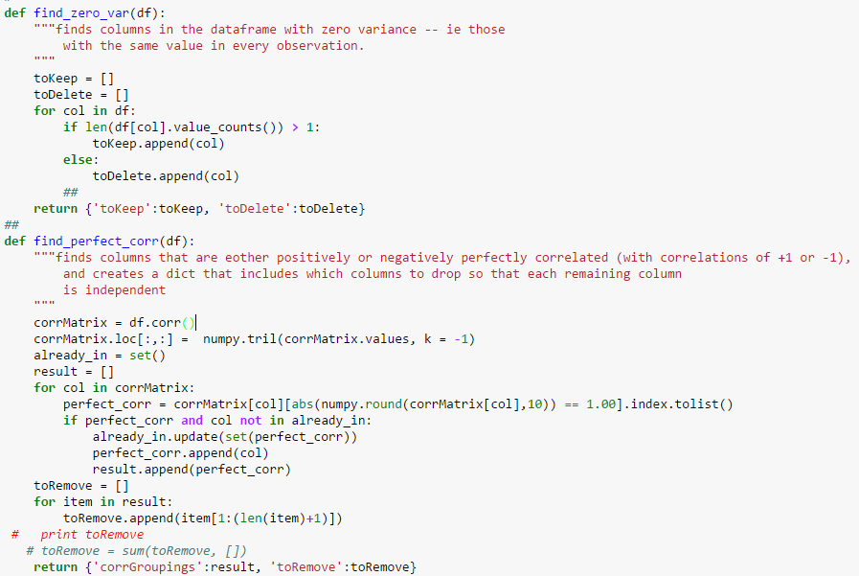

Figure 4: Cleaning functions to remove variables with no variance and perfect correlation

Once the user table is cleaned and split into an explanatory dataframe and response column the data is now ready to model.

The first model I ran was random forest. Using the default model, I was able to get an accuracy score of 0.98 which is more than the roc score of 0.98. To optimize this model I did a grid search as seen below.

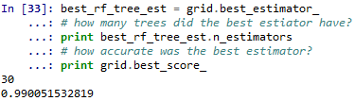

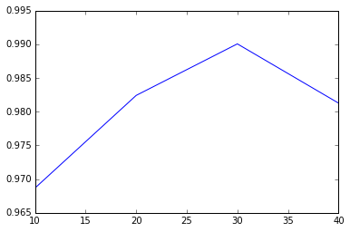

The next model I ran I doing boosting trees…..

In terms of importance, we found that fans were one of the more important indicators of whether or not someone was Yelp Elite.

Based on this finding, we decided to further segment the analysis to look at within Elite reviewers what were the key types of compliments that were likely to predict whether someone was an influential Elite reviewer or just a “run of the mill” Elite reviewer.

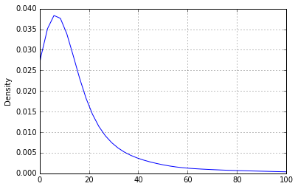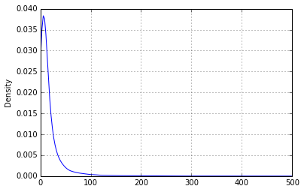

*Figure 8: # of Fans within Elite reviewers*

There is a stunning drop off in the # of fans elite members have. Based on the descriptive statistics, we used 20 as the cutoff for what was considered a high proportion of fans.

# Challenges, successes, and conclusion

In sum, the project had a few challenges that weren’t documented completely in the above details. For example, we began with the intention of running a cluster analysis on the users rather than trying to predict who was elite or not based on those characteristics.

The data was not setup in such a way to make cluster analysis useful so we decided to pursue a different option, which included the various classifier algorithms.

To take advantage of this template’s design, use the Styles gallery on the Home tab. You can format your headings by using heading styles, or highlight important text using other styles, like Emphasis and Intense Quote. These styles come in formatted to look great and work together to help communicate your ideas.

Go ahead and get started.